What to Expect and How to Prepare for a Summer Swim Meet

Everything your child has been working on at practice finally has a chance to come together at the summer swim meets. It is such a fun time to hang with friends, race in the pool and get to know all the other teammates and parents. However, it can also seem overwhelming for both swimmer and parent. Hopefully the following will help ease some of the anxiety that comes with uncertainty:

What To Pack for Your Swimmer(s):
- Sunscreen
- Goggles (an extra pair is always good to have on hand)
- Cap
- Towel
- Snacks / Lunch (watermelon, grapes, fruit is best to keep hydrated in the heat!)
- LOTS to DRINK

There is sometimes a lengthy wait between events, so many kids will pack a deck of cards, an iPad, games, etc. to help pass the time.

What to Pack for Parents:
- Chairs
- Tent / Canopy (Many families bring and setup tents to offer shade from the blazing sun. Don’t be shy, many people are happy to share their tent space if you don’t have one.)
- Cooler with food and drinks
- Black Sharpie marker (will explain later)
- Money for concessions
- Book, iPad, etc. (to pass the time between events)
- Heat Sheet (found on the team website)

Before the Meet Begins:
- Read the email(s) sent by the Coach!!! This will provide details about the venue address, warm up times, etc.

- Print off the Heat Sheet from the team website (may also be attached to the email coach sends out prior to each meet). Click on the Events tab, select the meet. There you will find several informational documents, including the Heat Sheet. Don’t forget to bring it with you! (Note: A Heat Sheet is the “program” for the meet. It lists the events in order and breaks down each event into heats and lanes).

- Check the Alphabetical Entry list to find all the events in which your swimmer is participating. This will make finding your swimmer on the Heat Sheet much easier.

- Using the Heat Sheet, find your swimmer under each of his/her events. Highlighting their event#, Heat#, Lane# and Name makes for easy reference throughout the meet. An example of a Heat Sheet is below:

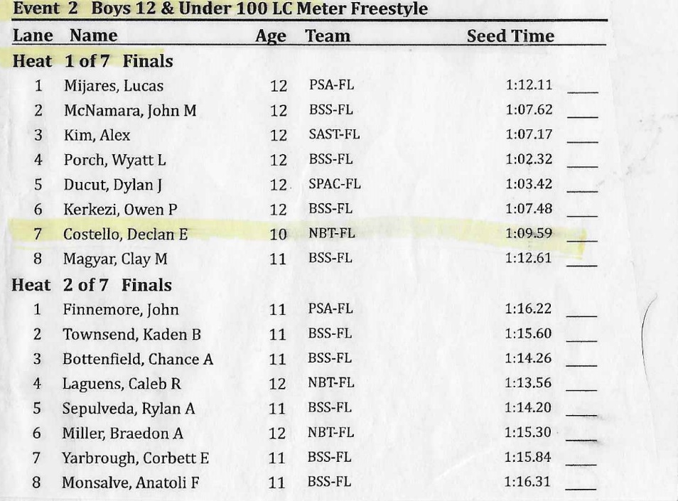

- Use the black sharpie to mark your swimmer’s Event, Heat, and Lane on their arm. Below is an example of how to mark your swimmer(s) based on the Heat Sheet:
E | H | L
2 | 1 | 7
10 | 1 | 8
Here is an image – you’ll see that the events are included here. We do suggest this as it only provides a little more clarity for both the swimmer and the ready bench volunteers.

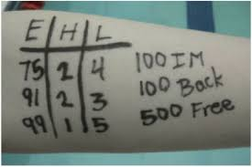

- On the back shoulder, write your swimmer’s last name, first name initial. Under that write our team name NBT. Below is an example:

Costello, D
NBT
During the Meet
- Upon arrival, the first thing you need to do is check your swimmer(s) in at the check-in table. If the location isn’t obvious, just ask someone. IF YOU ARE NOT CHECKED IN BY 7:15, THEN YOUR SWIMMER(S) MAY BE SCRATCHED (NOT SELECTED) FROM A RELAY. The check-in sheets enable the coaches to see who is and who is not on site. They in turn have to submit changes to the officials no later than 7:30 a.m.
- Every swimmer reports to the “Ready Bench” prior to their actual event. Think of this as the bull pen or holding area. Volunteers are there to check your swimmer in and organize him/her into the correct events and heats. Only volunteers that have signed up for the Ready Bench position are allowed in the area. Once you have delivered your swimmer to the ready bench, go to the pool and scout out the perfect spot to watch their event.
- Swimmers are typically called to the ready bench 4 to 6 events BEFORE the actual event they are swimming in. It is the EVENT that is called to report to the Ready Bench, not your specific swimmer.
- After your swimmer races his/her event, they can sit with you, play with friends, etc. until their next event is called to the Ready Bench.
- Remember to make sure your swimmer(s) is staying hydrated!!
- Team Relays happen at the beginning and end of each meet.
**Important: After your swimmer(s) finish their first individual event, please have them check-in with the coach to confirm if they have been added to a relay team or if a relay has been scratched. Please make sure your swimmer stays until the end of the meet if they are on the last team relay.

Volunteering at a Meet
- If you have signed up for a volunteer position at the meet, please find and check-in at the volunteer table.
- Listen for announcements prior to the start of the meet, as there will be a brief meeting for lane timers and officials.
- Please show up to your assigned position on time! It is critical that all volunteers are in place on time in order to start the meet and keep it moving forward.
- There will be two shifts during a meet. Please listen for the announcement half way through the meet, indicating when it is time for second shift volunteers to take over.
- Whether it’s a home meet or an away meet, parents are encouraged to help fill any open volunteer positions when announced. Meets cannot begin until every position is filled. You will be credited for any additional volunteer positions you unexpectedly take on at the meet.

After the Meet
- Be sure to pack up all your belongings. You are free to leave after your swimmer’s last event if they are not part of a relay team.
- Results will be sent via email by the coach once they are finalized

